EXPERIMENTS (2-9)

EXPT 2 : STAR TOPOLOGY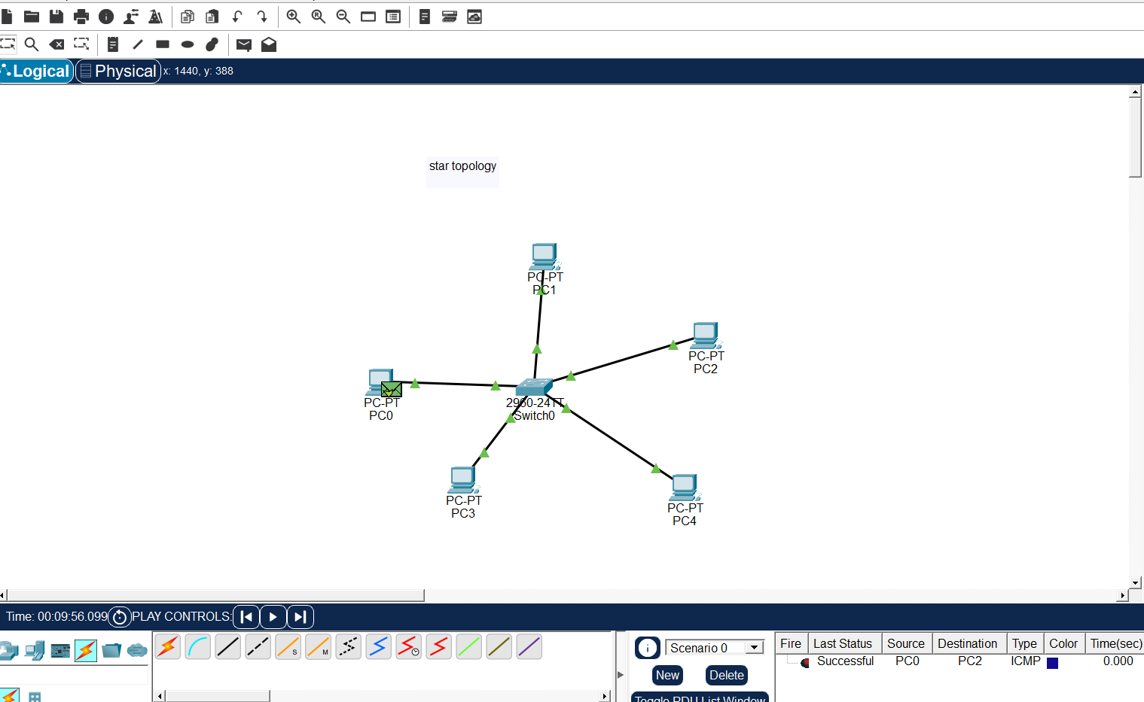
EXPT 3 : BUS TOPOLOGY
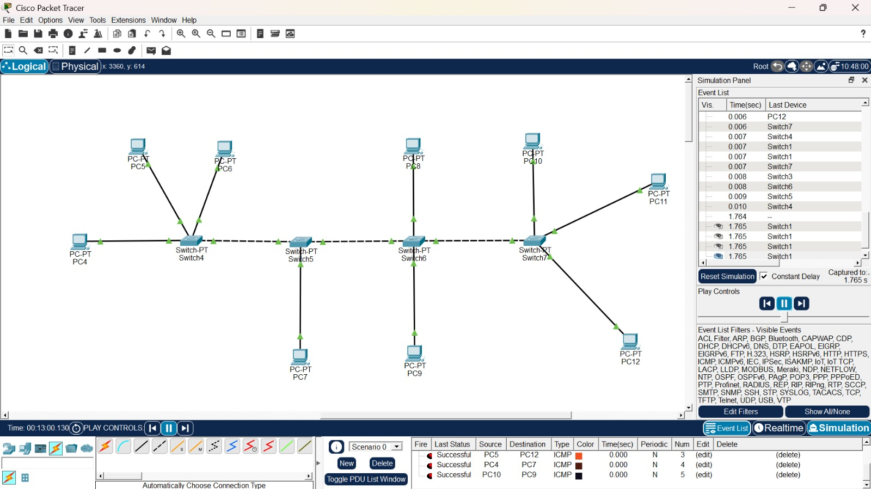

EXPT 4 : MESH TOPOLOGY
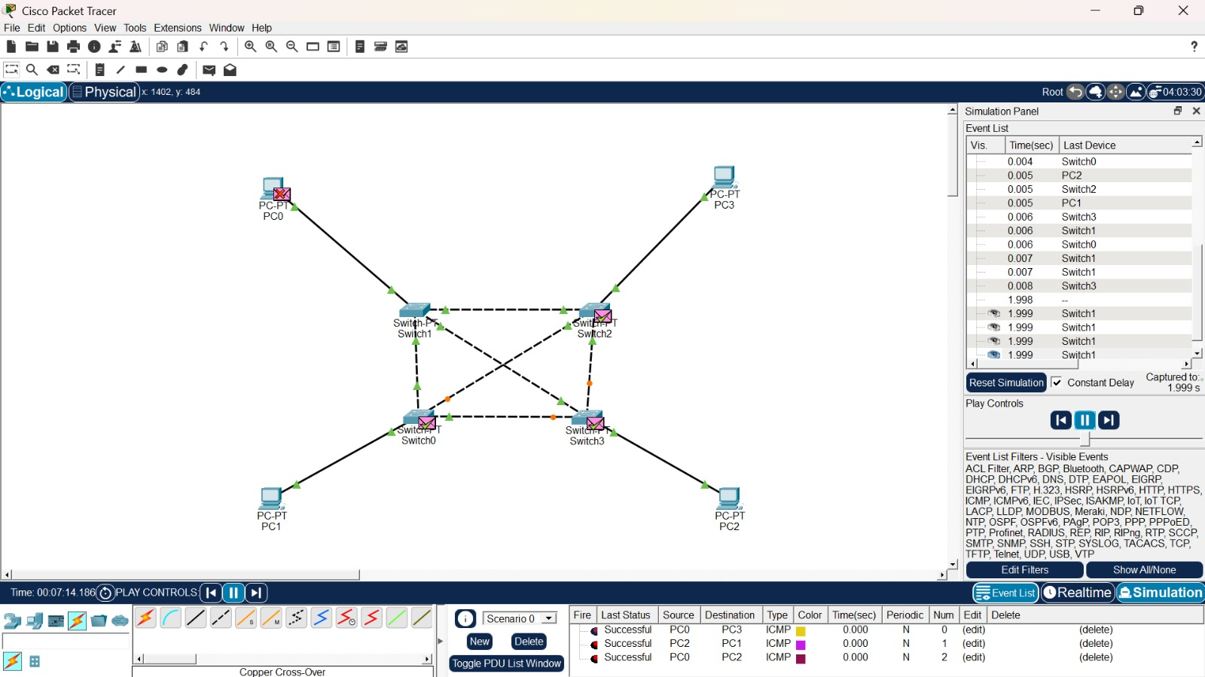
EXPT 5 : TREE TOPOLOGY

EXPT 5 : HYBRID TOPOLOGY
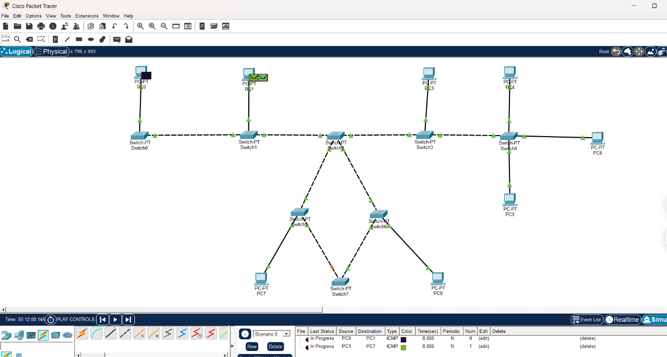

EXP 6: HYBRID TOPOLOGY
